|  |  |  |
| --- | --- | --- |
| ***PAF-KIET LOGO Small File222PAF – Karachi Institute of Economics and Technology – City Campus*** | | |
| ***Course: Principles of Management*** | | |
| ***Faculty:Muzammil Ahmed*** | **Max Duration** | **2 Hours** |
| ***Class ID:106200*** | ***Total Marks:*** | **25** |
| ***Examination: Final Term (Spring 2021)*** | ***Date:06-05-2021*** | |

**Name: Shahmeer khan.**

**Student ID: 12113.**

**Case Study: 15 marks**

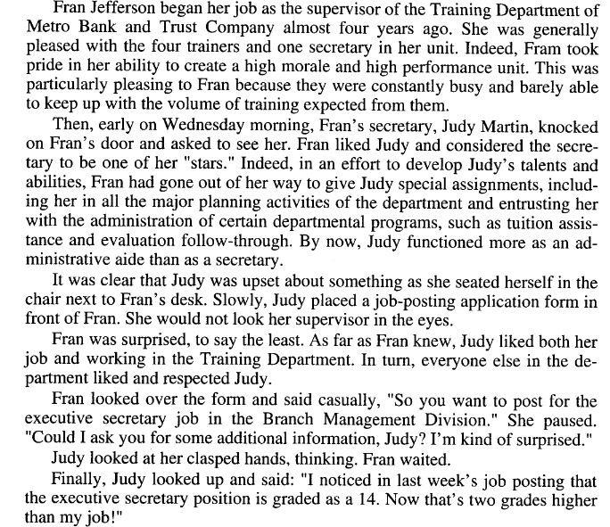

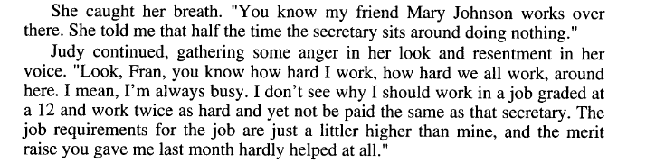

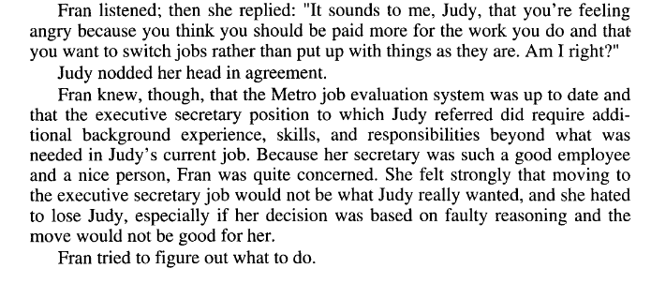

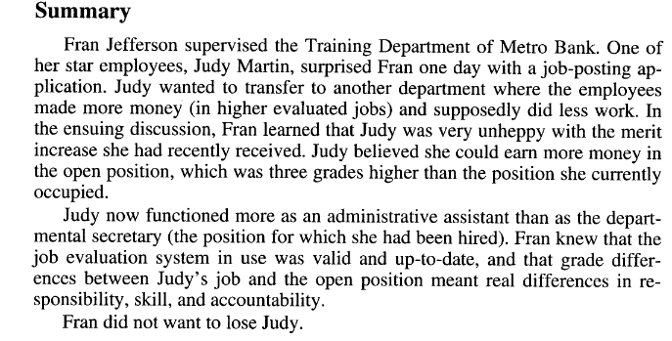

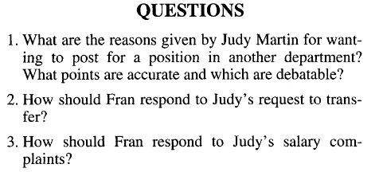

Ans-1: The reasons were that Judy noticed that executive secretary position was graded as 14 and that was 2 grades higher than her job and she got to know through her friend Mary Johnson that the secretary does nothing and here she is doing double the work she has to do and yet she is not getting the pay she deserves since she is doing more than a secretary does in his own job and is paid more than her and since the job requirement in she applied for were a bit high than her and her current ones and I think these points are debatable. So yeah with her hard work she does I also thinks she made that decision in anger with only in keeping in mind that she works hard and gets less paid, which might be not good or not good enough for her.

Ans-2: Fran has to take actions and to does that she has to make Judy believe that she is going to do justice for Judy’s hard work and the things she deserves after being a hard worker and whatever the action Fran will take it must surprise and delight Judy that Fran’s next action should be what Judy will remembers in a positive way since she is working to win back Judy’s trust.

Ans-3: Fran should do something realistic and reasonable act to make sure Judy that her salary problem is getting out sorted soon and win Judy’s Trust with the act whatever she will take or do, or then she might have to lose Judy then.

**Q2)** **5 marks** 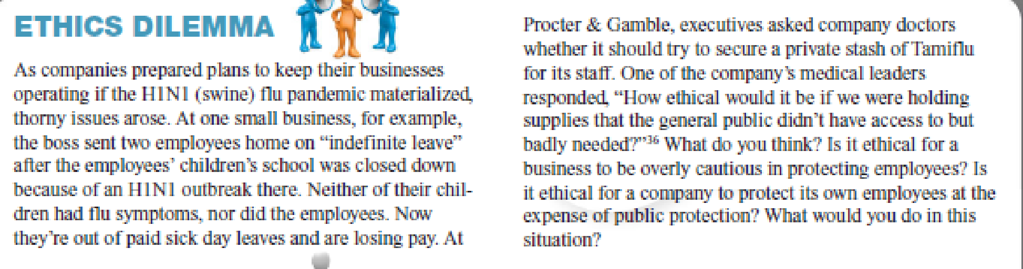

Ans-2: Will wait to get the situation cool down first then will make the working by making rules and considering to follow the SOP’s and will make seceretive and brave steps to balance both situation which are of protecting employees and expenses of public protection and might hire young employees who will work under the guidance of those employees (secrertely having the view of SOP’s in mind) who needs overly cautious protection.

**Q3)5 marks**

Most of us have to work for a living, and a job is a central part of our lives. So why do managers have to worry so much about employee motivation issues? Can an individual be too motivated?

Discuss.

Answer-3: The employee’s motivation thing is a crucial thing which also effects a bit on the job of manager’s if an employee is a bit down in working or lacking motivation because employees makes the projects of company and the whole company is 50% depending on them since it is on them and on the managers to make an attractive productive product which might results in increase in company’s profit if the product is an hit in the market. And if an employee is lacking motivation so it might results in his work on company’s project in a negative way and manager also gets closer in the eye of Top management of the company that is he doing his thing of motivating his own employees or not because these are the managers who have to control the employees and sees their direction towards the company’s project making that are they doing the work with positivity and passion or not.